**Project Design Phase**

**Solution Architecture**

| Date | 27 June 2025 |
| --- | --- |
| Team ID | LTVIP2025TMID59202 |
| Project Name | SmartSDLC – AI-Enhanced Software Development Lifecycle |
| Maximum Marks | 4 Marks |

**Solution Architecture:**

The solution architecture for our project outlines a structured approach to developing a machine learning application, starting from data collection and preprocessing to model building and deployment. Data is initially gathered from structured sources and processed using Python libraries like Pandas and Scikit-learn to handle missing and categorical values. The cleaned data is then used to train and test machine learning models, ensuring accurate predictions. Finally, the trained model is integrated into a user-friendly web interface using Flask and HTML for real-time interaction. This architecture ensures a seamless data flow, modular development, and scalable deployment, aligning with the project goals and agile sprint structure. The design is inspired by real-world architecture patterns, such as those presented in AWS's clinical voice application framework.

**Example - Solution Architecture Diagram:**

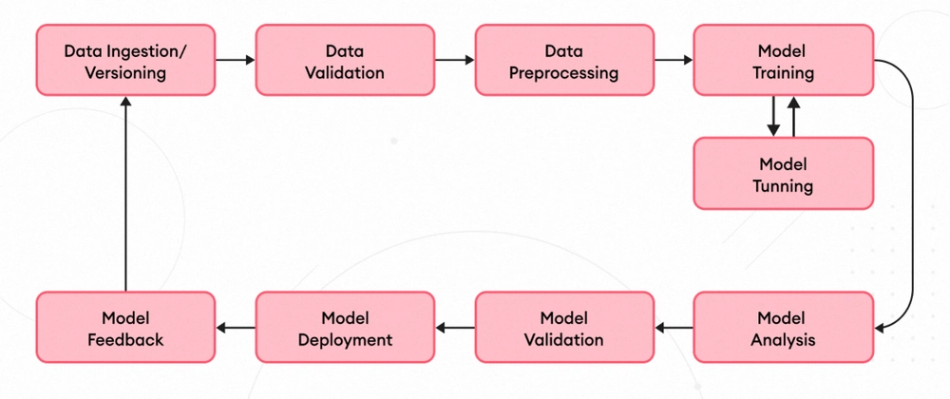

*Figure 1: Smart SDLC: End-to-End Machine Learning Architecture*

**Reference:** <https://medium.com/@mark.southworth98/utilising-ai-ml-to-improve-the-software-development-lifecycle-b0b6fa961cf6>